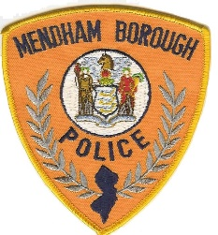
Mendham Borough Police
3 Cold Hill Road South
Mendham, NJ 07945
973-543-2993

Hiring Announcement

As of January 8th, 2021, the Mendham Borough Police Department is now accepting applications for the position of full-time Police Officer.
Minimum Qualifications:
- Be a citizen of the United States and a resident of New Jersey;
- Be at least eighteen (18) years of age and possess a valid NJ Driver License;
- Be sound in body and of good health sufficient to satisfy the Board of Trustees of the Police and Firemen's Retirement System of New Jersey as to their eligibility for membership in the retirement system;
- Be of good moral character. No person shall be appointed who has been convicted of an indictable offense or who has been convicted of any crime or offense involving moral turpitude;
- Read, write, and speak the English language well and intelligently;
- Possess the ability to perform all the tasks and duties of a Police Officer;
- Pass a medical and psychological examination;
- Pass an extensive background investigation to include drug screening;
- Must possess a minimum of sixty (60) college credits from an accredited college or university, or two (2) years of military service with an honorable discharge;
- Must possess a current New Jersey Police Training Commission (PTC) certification, be an active police academy recruit or possess another NJ PTC certification that is waiver eligible and;
- Be under no contractual obligation to another department under N.J.S.A. 40A:14-178 or must be willing to satisfy any training reimbursement to a prior department.

Applications may either be picked up during regular business hours at the police desk, or downloaded from the Mendham Borough Police Department webpage, located at mendhamnj.org. Completed applications and attached resumes must be submitted either in-person or via email to mbpdrecruiting@mendhamnj.org no later than 4:00pm on February 12th, 2021.

The Mendham Borough Police Department is an Equal Opportunity Employer.

