WOODBURY HEIGHTS POLICE DEPARTMENT
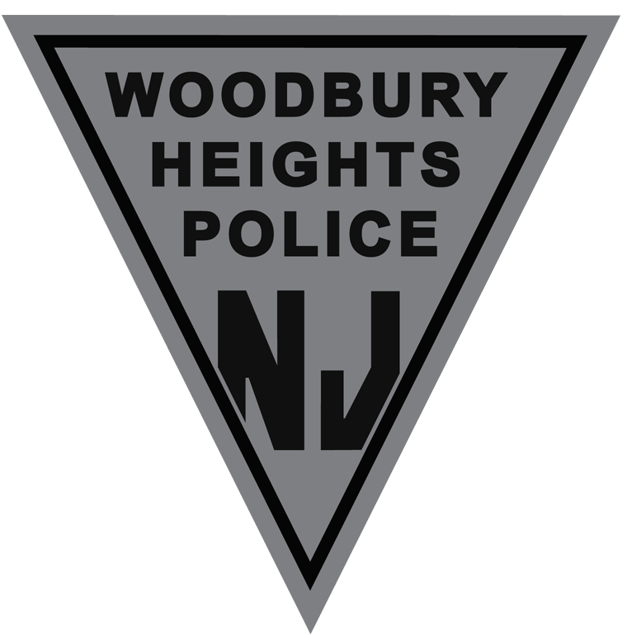
500 ELM AVENUE
WOODBURY HEIGHTS, NJ 08097

JOSHUA M. MOLINE TELEPHONE NUMBER: (856)848-6707
Chief of Police EMERGENCY CALL 911
NON-EMERGENCY: (856)589-0911
FAX: (856)853-2995

Woodbury Heights Police Department
HIRING ANNOUNCEMENT

The Woodbury Heights Police Department is now accepting applications for the position of Class II Special Law Enforcement Officer (SLEO II). Applicants shall possess a current New Jersey Police Training Commission SLEO II Certificate and be under no contractual obligation to another department under NJSA 40A:14-178 or must be willing to satisfy any training reimbursement to a prior department.

Eligibility:

- Is a citizen of the United States and resident of New Jersey.
- Is able to read, write, and speak the English language well and intelligently.
- Is of good moral character, sound body, and good health and shall never have been convicted of any criminal offense involving moral turpitude.
- Must be at least eighteen (18) years old.
- Shall have vision correctable to 20/20 vision in each eye and shall have normal color perception.
- Shall have 15/15 hearing in each ear without artificial aids.
- Must possess a valid New Jersey driver’s license.
- Shall satisfactorily pass a physical and medical examination
An offer of employment is contingent upon a satisfactory background check, medical examination, and psychological examination.
Interested applicants can find the EMPLOYMENT APPLICATION at http://www.bwhnj.com/forms/. Applicants should hand deliver the application, resume, NJPTC Certificate and photo ID to WHPD 500 Elm Avenue Woodbury Heights, NJ 08097 by April 1, 2020 at 4:00PM.

