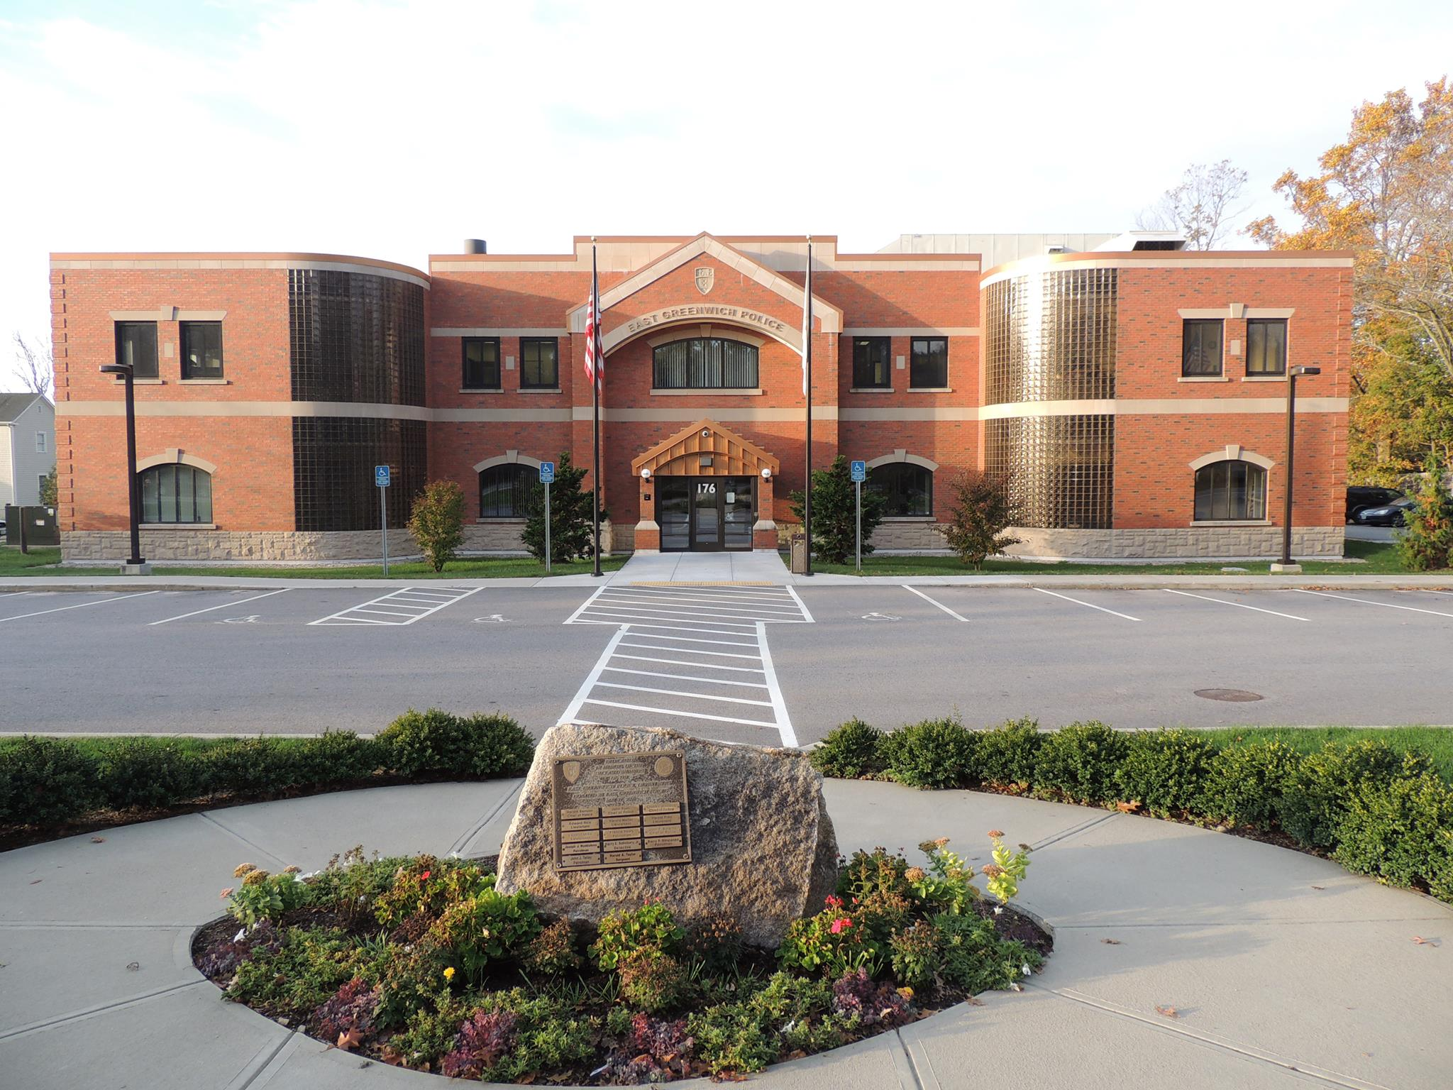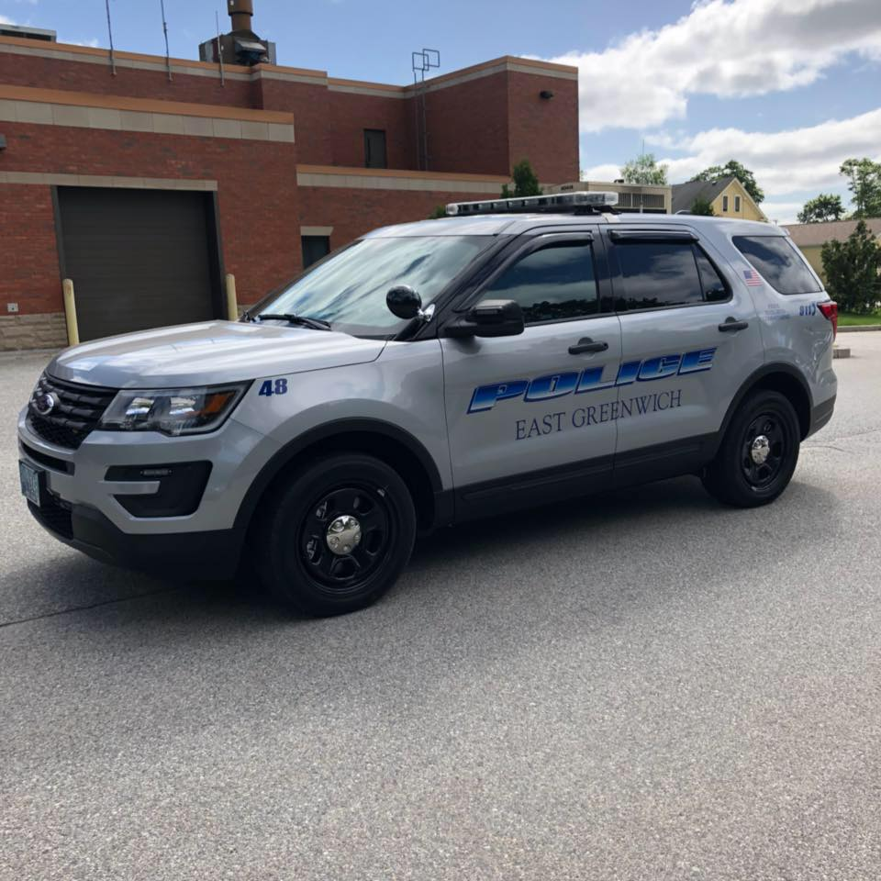    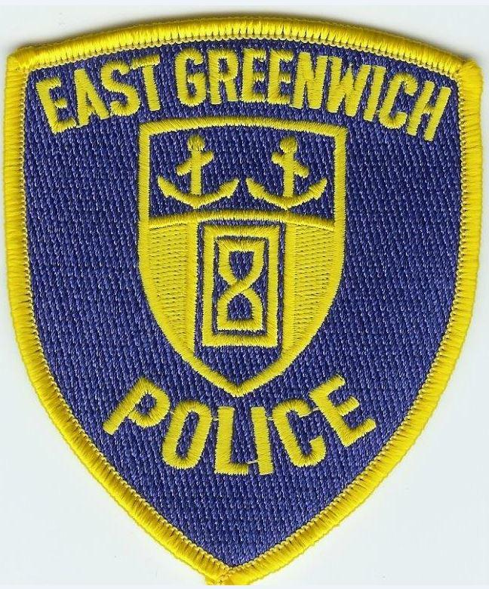  - eAST gREENWICH pOLICE  lATERal rECRUITMENT  Application Process  The East Greenwich Police Department is currently accepting application for the position of police officer. We are currently seeking officers that would like to continue their careers with a new department.  - No written or physical agility test  - Abbreviated FTO process  - Apply at www.policeapp.com | Starting base salary $55,000 per year  Reach top step salary of $65,000 within two years  ____  Ability to Accrue COMP time and Longevity pay  ____  13 Paid Holidays  ____  Health coverage available post retirement  ____  Time and a half weekend detail rate  ____  12-29 Vacation days per year based on years of service after probation  ____  Two personal days per year  East Greenwich Police Department  176 First Ave.  East Greenwich, RI 02818  401-884-2244

