VALLEY COUNTY SHERIFF’S OFFICE
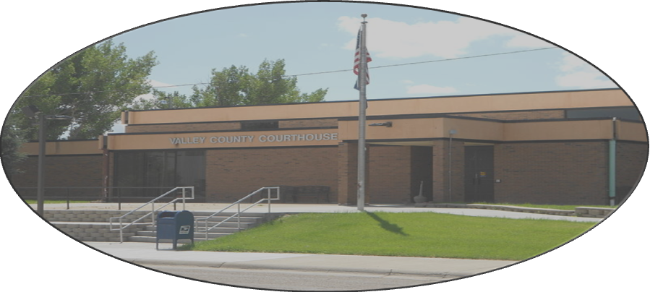
Thomas Boyer
Sheriff / Coroner
Telephone:
501 Court Square, #10 (406) 228-4333
Glasgow, MT 59230 Fax:
vcsheriff@valleycountymt.gov (406) 228-4601

AUTHORIZATION FOR RELEASE OF INFORMATION

I, ______________________________________,
(First, Middle, and Last Name)

Do hereby authorize a review, full disclosure, and release of any and all records concerning me, that the Valley County Sheriff’s Office properly determines relates to the applicant’s qualification for a position as a Deputy / Dispatcher / Detention Officer to any duly authorized officer, agent, or employee of the Valley County Sheriff’s Office, whether the records are of a public, private, or confidential nature.

______________________________ ____________________
Signature Date

______________________________ ____________________
Social Security Number Date of Birth

______________________________ ____________________
Driver’s License Number DL State of Issuance

