Testing
Written Examination (CT Police Chief’s Test)
Physical Agility (Entry Level Applicants)
Oral Board
Chief's Interview
Background Investigation*
-Character -Employment
-Criminal History
-Motor Vehicle Driving Record
Drug Screening Test
Polygraph Examination
Psychological Examination
Medical Screening
*To include but not limited to.

Compensation

The starting salary for a recruit will be $66,594, increasing to $74,252 after 1 year. The starting salary for CT POSTC-certified police officers with 1 or more years of experience will be $74,252.

Benefits include:
- Health and Dental insurance
- Tier IV CT State Employee Retirement System
- Vacation, Sick, and Personal Leave time
- Deferred Compensation
- Group Life Insurance
- Tuition Reimbursement


Connecticut State Capitol Police
300 Capitol Avenue, Room 1300
Hartford, CT 06106-1591
WWW.CGA.CT.GOV/COP



Connecticut State Capitol Police



“Protecting Democracy”
An Equal Opportunity Employer

Mission Statement

The mission of the Connecticut State Capitol Police is to support the State Legislature by creating a safe and secure environment in which to conduct the legislative process. We will carry out this role in a manner that respects the rights and dignity of all persons.

Core Values

- Integrity
- Duty
- Respect
- Tolerance
- Honor



The Connecticut

State Capitol Police
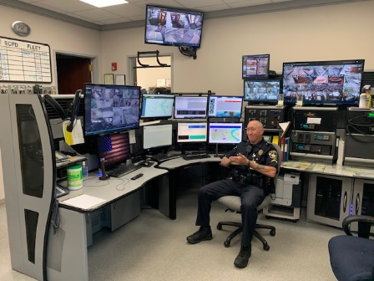
In 1974 the State Legislature created the Office of the State Capitol Police. The office grew from its original complement of seven officers to a staffing level that includes nineteen Officers, six Corporals, five Sergeants, two Lieutenants, and the Chief of Police.
State Capitol Police Officers are respon- sible for meeting the law enforcement and public safety needs of the General Assembly. Officers patrol a seventeen-acre complex that
includes the State Capitol building, the Legislative Office Building, and the Legislative parking garage. Over 100,000 people visit the complex every year. Since this is the focal point of state government, officers work in an exciting environment that respects the divergent views and opinions of legislators, staff, and visitors.
Officers are required to meet and maintain police officer certification standards, as mandated by state law and regulated by the Police Officer Standards and Training Council. The department has been nationally accredited through the Commission on Accreditation for Law Enforcement Agencies Inc. (CALEA) since 2003. The department also earned state accreditation in 2006. In addition to certification standards, officers must maintain emergency medical response certification at an EMR level.
More information about the department can be found on our website at:

WWW.CGA.CT.GOV/COP

The State Capitol Police provide 24 hour 7 day a week coverage throughout the year.


To apply and receive more information on the hiring process for The Connecticut State Capitol Police please visit:

WWW.POLICEAPP.COM

