Testing

Written Examination

Oral Board

Chief's Interview

Background Investigation*

-Character -Employment

-Criminal History

-Motor Vehicle Driving Record

Drug Screening Test

Polygraph Examination

Psychological Examination

Medical Screening

*\*To include but not limited to.*

Compensation

The starting salary for CT POSTC certified police officers with between 2-5 years will be $64,367.

The starting salary for CT POSTC certified police officers with 5 or more years of experience will be $68,951.

Benefits include:

* Health and Dental insurance
* Tier IV CT State Employee Retirement System
* 3 weeks vacation, Vacation, Sick and Personal Leave time
* Deferred Compensation
* Group Life Insurance
* Tuition Reimbursement



**Connecticut State Capitol Police**

**300 Capitol Avenue, Room 1300**

**Hartford, CT 06106-1591**

[**WWW.CGA.CT.GOV/COP**](http://WWW.CGA.CT.GOV/COP)



Connecticut State Capitol Police



***“Protecting Democracy”***

**An Equal Opportunity Employer**

# Mission Statement

The mission of the Connecticut State Capitol Police is to support the State Legislature by creating a safe and secure environment in which to conduct the legislative process. We will carry out this role in a manner that respects the rights and dignity of all persons.

# Core Values

* **Integrity**
* **Duty**
* **Respect**
* **Tolerance**
* **Honor**



# The Connecticut

# State Capitol Police

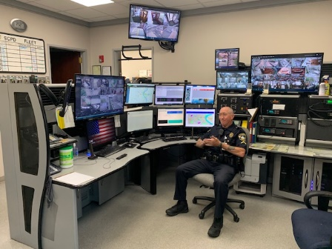In 1974 the State Legislature created the Office of the State Capitol Police. The office grew from its original complement of seven officers to a staff- ing level that includes nineteen Officers, six Cor- porals, five Sergeants, two Lieutenants, and the Chief of Police.

State Capitol Police Officers are respon- sible for meeting the law enforcement and public safety needs of the General Assembly. Officers patrol a seventeen acre complex that

includes the State Capitol building, the Legisla- tive Office Building, and the Legislative parking garage. Over 100,000 people visit the complex every year. Since this is the focal point of state government, officers work in an exciting envi- ronment that respects the divergent views and opinions of legislators, staff, and visitors.

Officers are required to meet and maintain police officer certification standards, as mandated by state law and regulated by the Police Officer Standards and Training Council. The depart- ment has been nationally accredited through the Commission on Accreditation for Law Enforce- ment Agencies Inc. (CALEA) since 2003. The department also earned state accreditation in 2006. In addition to certification standards, of- ficers must maintain emergency medical response certification at an EMR level.

More information about the department can be found on our website at:

[WWW.CGA.CT.GOV/COP](http://WWW.CGA.CT.GOV/COP)

The State Capitol Police provide 24 hour 7 day a week coverage throughout the year.



**To apply and receive more information on the hiring process for The Connecticut State Capitol Police please visit:**

[**WWW.POLICEAPP.COM**](http://WWW.POLICEAPP.COM/)

