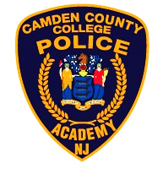

The next Selection Process for the Camden County College Police Academy Alternate Route Program is set to begin.

The program will kick off with an Information Session on Wednesday July 17, 2025 at 5:00 PM.

The Alternate Route Program information session will be held at the Thomas G. Stewart III Memorial Auditorium at the Regional Emergency Training Center on the Lakeland Campus of Camden County College 420 N. Woodbury – Turnersville Rd. Blackwood N.J. 08012.

- Written Test Registration is limited to 160 applications
- Payment is due at the time of registration on PoliceApp.Com.

The Written Test is scheduled for Saturday September 27, 2025. All candidates must be in line for check-in by 08:00am.

